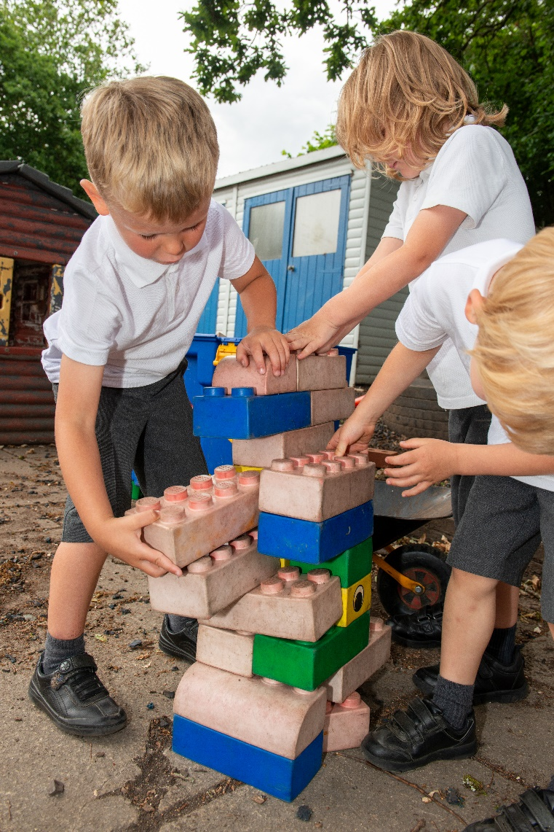

Reception 2025
Parent Information

Reception Class Teacher: Mrs Kate Guillaume

School Office: 01252 876106
Email: adminoffice@potleyhill.hants.sch.uk

Website: www.potleyhill.hants.sch.uk



Welcome to Potley Hill Primary School. The following information aims to support you as your child transitions into school and completes their Reception year.

Start Dates
Autumn born children attend school full time from September. Spring and Summer born children have the opportunity to be in school full time from the beginning of the academic year. Please contact the school if you do not feel that your Spring or Summer born child is ready for full-time schooling in September and this can be discussed further.

When school returns in September 2025 our Reception staff will spend the first few days carrying out Home Visits. This is something that has happened for the past few years and we have found it has had a positive impact on the transition of pupils because when they then start school they would have seen the staff very recently and will feel more comfortable coming in to the classroom with them.

Children will then transition into Reception Class over a series of three days from Tuesday 9th September until Thursday 11th September – by this third day, all children will be in school full-time:

Group 1 – start on Tuesday 9th September for a ‘normal’ school day - 8.40am until 3.20pm. These may be some of our younger children, those with SEN or others who may find the transition tricky. We will talk to parents/carers about any concerns regarding starting school following our New Reception Information Evening on Wednesday 18th June.
Group 2 – along with Group 1, Group 2 start on Wednesday 10th September - 8.40am until 3.20pm.
Group 3 – along with Groups 1 & 2, Group 3 will start on Thursday 11th September - 8.40am until 3.20pm, joining the rest of the class to make the full cohort. These are likely to be our most confident, and possibly Autumn-born children.

Doors are always open from 8.40am and children can be dropped off any time between 8.40am and 8.50am. We expect all children to be punctual so please leave plenty of time to get them into class.

All parents are asked to complete a form identifying the end of the day collection arrangements for their child. Parents may nominate more than one person who has permission to collect their child.

If your child is being collected by someone other than those named on the above form, you will need to inform the class teacher in writing. If written confirmation is not received, we will not allow your child to go until we have spoken to you. This procedure is put in place for your child’s safety. In an emergency, you may telephone the school office to inform them of an alternative collection arrangement.

Kidz R Us
If you require supervision of your child/ren before/after the school day, our wrap-around-care provider is Kidz R Us. The provision is offered on school site with Breakfast Club starting from 7.30am and After-School Club lasting until 6.00pm. Please see the leaflet in your pack for further details.

Uniform
The school uniform policy is available via the uniform section of our school website, which can be found here (https://www.potleyhill.hants.sch.uk/page/?title=Uniform&pid=67) on the uniform section of our website and we pride ourselves on a smart appearance and ask for your support in achieving this.

School uniform with the Potley Hill motif is available from;

Brenda’s Schoolwear, 130 Frimley Road, Camberley GU15 2QN.
Telephone: 01276 469697 or https://www.brendas.co.uk/collections/potley-hill

Brenda’s offer parents the option of online shopping with home delivery too.

My Clothing at https://myclothing.com/potley-hill-primary-school/17291.school for home delivery
Alternatively, the Potley Hill PTA run a used uniform shop https://app.uniformd.co.uk/items/163

Book Bags
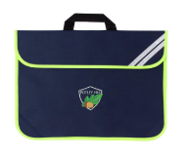
You can purchase a blue Potley Hill book bag for your child from our uniform providers. This needs to be in school every day as it is helpful to carry any phonics books, library books or home learning between home and school.

All of these arrangements will be explained to parents/carers before we start to use them in September.

We also ask for each child to have spare underwear and socks stored in their book bags daily in case of any accidents.

At the end of each school day, please check your child’s book bag to see if there are any letters because whilst we try to be ‘paper-free’ there are some circumstances where flyers or permission slips are distributed. The school issues a weekly bulletin; this is sent via our Arbor system and is also available on the school website.

If there are any reply slips that need to be returned to the school, please return them to the class teachers via your child as this encourages independence and responsibility.

PE Bags
PE bags can be purchased from either of our uniform providers and should match the colour team which children are put into on entry into Reception. Please ensure that your child’s PE kit is in school all week. Every item, including plimsolls, need to be named. Although we have timetabled PE sessions, there may be other times that children need their PE kits. We will let you know PE days in September.


The following should be in their PE bags at all times:

- Navy PE T-shirt
- Navy Shorts
- Plimsolls
- Socks (for girls wearing tights in
the winter)
- Long Dark tracksuit trousers (for outside activities in winter)
- Optional navy sweatshirt or school jumper for cold weather

We ask that children do not wear earrings on PE days. We cannot remove earrings for children so please teach them how to do this themselves in case they need to be removed at any other time. Please provide a named container to keep the earrings in.

Children will be expected to undress and dress themselves for PE independently. For this reason, please choose shirts/dresses that are easy for the children to undo and please practise this at home.

PE bags are brought home every Friday by your child so that PE kits can be washed and returned to school on Monday.

Wellington Boots and Waterproof Clothing
Please provide a pair of named wellington boots and puddle suit or similar waterproof covering for your child to be kept at school. In Reception, lots of learning takes place outdoors and in all-weather types. Children do love to go out and play in the school grounds, but this will only be possible if your child has wellies in school and ideally a form of wet weather suit they could put over their uniform easily.

Water & Healthy Snacks
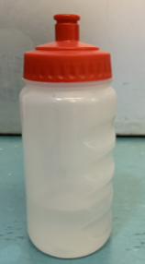
Please ensure that your child has a named bottle of fresh water in school every day. Children's behaviour and concentration will be much better if they have access to drinking water on a regular basis. The bottle needs to be easy for your child to open and drink from; however, it needs to have a valve which stops the water leaking if the bottle is laid on its side.

Your child will also receive a FREE piece of seasonal fruit or vegetable every day at school. If your child does not like a particular food, they will be encouraged to try a little bit. Children’s taste buds are ever changing and it can take up to 15 tastes to learn to like a food. Please make us aware if your child has any allergies.
Lunch
Your child has a choice of school dinners or a packed lunch brought from home.

A school dinner menu will be sent home in the weekly bulletin each Friday, showing dinner options for the following week. There are 3 or 4 meal choices each day and the menu rotates on a 3-weekly cycle.

School dinners are currently free for all children in Reception to Year 2 and provide a nutritionally balanced hot meal. This is known as Universal Free School Meals. Alternatively you can provide your child with a packed lunch – these should also be ‘healthy’ and avoid chocolate covered or high-sugar items, sweets of any kind and nuts (this includes chocolate spreads which contain nuts too). Children are allowed a soft drink to have with their lunch but no fizzy drinks. Please also cut up large items into manageable pieces and ensure that the lunch bag/box is named.

Your child may also be eligible for Free School Meals, which means that once they progress to Year 3, these meals continue to be free. In addition, the school receives additional funding to support their academic progress which we use to provide clubs, additional support in class and give discounts on trips and visits. If you think your child may be eligible, please look on the school website under the ‘Parent Information’ section then ‘School Dinners’, where you will find a link which gives you further guidance and enables you to apply for Free School Meals or type in the following web address https://apply.cloudforedu.org.uk/ofsm/hants. The school office will be notified automatically if your application is successful.

Lunchtime Supervisors are also on hand to help children whenever necessary. The Reception staff will also support the children when they first go into the dinner hall. Water is also available for your child to drink.

We never throw any food from lunchboxes away. Anything not eaten will be left in your child’s lunch box as this ensures that you are aware of what your child is eating. It is well worth giving your child the opportunity to practise using their lunch box at home before bringing it to school.

YOUR CHILD IN SCHOOL

Class Reading
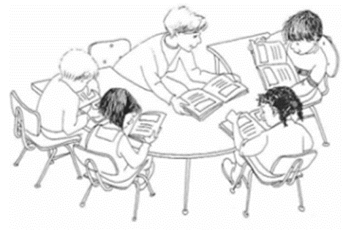
Class reading takes place three times a week. Reading daily to an adult is essential to help each child progress. The class teacher will aim to listen to each child read once a week.

At school the reading session will be as a guided group read session rather than on a 1:1 basis. The children will read their group book in school 3 times. At this stage the children should already be able to read the book and now need to focus on their fluency and comprehension of the text.

School Productions and Class Assemblies.
All the children in Reception will perform in a Christmas production and there will be a further opportunity to take part in a class assembly in the school year to which parents are invited. You may be asked to provide a specific costume which will need to be brought into school in a bag clearly labelled with your child’s name.

Illness
If your child is unwell and unable to attend school, please contact the school office before 9am.


If your child has been ill with a sickness bug/diarrhoea, at least 48 hours needs to have passed after the last episode of illness before they should return to school. There may be some exceptions to this such as irritable bowel syndrome or illness caused by allergies.

If your child is unwell during the day and we feel that they need to go home, we will contact you immediately on the contact numbers that you have given the school office. It is very important that you keep us up to date with any changes to your contact details by contacting the school office directly.
Forms regarding medical issues and allergies are enclosed in the pack, please complete these, indicating whether your child has medical issues/allergies or not. Also, please remember to let the School Office know of any future medical changes so that your child’s records can be updated straight away.

We are able to administer ‘prescribed medicine’, such as antibiotics and asthma medication, if your child requires this during the school day. Prescribed medicines can only be administered if they have the pharmacists label on them. These will need to be taken to the school office by an adult where you will need to complete a form detailing the prescribed medicine and required dosage. The medicine will be kept in a fridge in the School Office if required and an adult will need to collect at the end of each day or if for long term use, such as an inhaler, it is kept securely in the classroom.

We are also able to provide Paracetamol suspension and Antihistamine syrup, with parents’ permission, for urgent use when required, (consent form is enclosed in the pack). However, if you know that your child is likely to need paracetamol/antihistamine during the day, please supply school with this.

Holidays during Term Time
Please note that holidays during term time are NOT authorised unless there are particularly exceptional circumstances. Exceptional circumstances do not include reasons linked to cost. There are 13 weeks of holiday built into the academic year and parent/carers are encouraged to plan any holidays within these times. It is Hampshire County Council’s policy to issue Penalty Notices to families where children have taken unauthorised leave of 10 sessions or more (5 days) in any 100 day period; these days do not have to be consecutive. Non-payment of Penalty Notices leads to a prosecution unless they have been issued incorrectly. Penalty Notices are now only usually issued once before the County goes straight to a prosecution. The school does not benefit in any way financially from these Penalty Notices, but all schools in Hampshire follow these same procedures.

Seesaw
Across the school we use a software program called ‘Seesaw’. This is an online resource that allows class teachers to share information with parents, e.g. special events, things to remember, photos from within class, but it can also act as a tool for communication between teachers and parents. In Recpetion, we use Seesaw to share photos of children carrying out activities alongside examples of work which allows parents/carers to enjoy all their child’s lovely moments at school as well as sharing lovely moments from home - all evidence towards the Early Learning Goals.

If you have a message to give to the class teacher, we would ask that you communicate this via Seesaw. Drop off and pick up times are very busy and staff may not always be available to talk. You can share messages this way as well as booking a time to speak to the teacher if needed. Login information will be shared with parents during home visits and the Seesaw app will be used throughout your child’s time at Potley Hill Primary School.

Parents/Carers will receive login details for the Seesaw App when they join in September.

Emotional Health and Wellbeing

Your child’s emotional health and wellbeing are paramount. We will endeavour to settle them into school as quickly as possible and support them with any wobbles in the morning. It is often the case that leaving mum or dad is the trickiest time of the day for young children (and sometimes parents too)! We recommend that you keep this time short, give some lovely kisses and cuddles – and then depart. This is not to be unkind, but to help the child move on to the activities of the day quickly and refocus their attention. In the vast majority of situations, children very quickly turn around any upset and are smiling and happy after only a few minutes. For this reason, we may give you a quick ring to confirm they are settled if there are any issues with drop off in the morning – we do not want parents/carers to be worrying all day either! We also run a full programme of PSHE (Personal, Social & Health Education). This includes aspects of mindfulness and children also participate in sessions designed to help them to identify and regulate their emotions, including using an emotional check-in.

SUPPORTING YOUR CHILD AT HOME

Reading Books
At school we teach children to read through daily phonics lessons using ‘Little Wandle Letters and Sounds’ phonics scheme. Your child will be reading books from the Collins Big Cat reading scheme that runs alongside the phonics we are teaching. Teachers in the class will provide each child with a text closely linked to the stage being taught at school.

To begin with, your child will bring home a ‘lilac’ book which may not contain any words, please talk about the pictures and encourage your child to tell you the story in their own words. All children learn at a different pace and some children may find this a little difficult at first.

Along with their reading book your child will bring home information related to an app called ‘Boom Reader’ which allows parents and staff to make comments about children’s reading. When you read with your child at home, we would appreciate you adding a comment on the Boom Reader app. A record of positive comments and any observations or concerns regarding their reading will help us work together to develop your child’s reading skills. Children are expected to read at home a minimum of 4 times a week. When your child reads on an individual basis to an adult in school, you will see that a comment has been added to your child’s account on the app. All group reading sessions will be recorded on our internal tracking sheets.

As well as a phonics book, children will also be given a library book to read for pleasure. The aim is not for the children to be able to read this to you, but for you to enjoy sharing the story with your child and you can also add these reads to Boom Reader. We have ’50 Must Read Books for Reception’ and these books can be borrowed from the School Library and Class Area. We encourage children to read as many of them as possible.

All children will also have access to SORA, the Hampshire School Library Service’s Collection of audio books, ebooks, “read along” books and magazines which are all free to read, and can also count towards weekly reading that can be recorded on Boom Reader.

Here are some ways that you could discuss the book with your child:

- Encourage them to tell you what is happening in the picture.

- Ask them ‘open’ questions, beginning with words such as Why? Where? What? and How? This will encourage them to answer using full sentences.

- Ask them to tell you the colour of something in the picture, or how many of an item there might be.

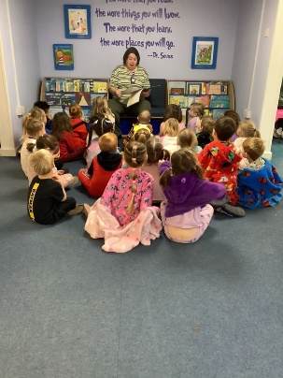
Library Books
A few weeks into the autumn term, the children will begin to visit the School Library on a regular basis. In Reception, the library books are for you to read and enjoy with your child. Please ensure the library books are in their book bag on library day. We will let you know which day this will be on in September.

Your child will have been working very hard to learn to read and it is also important for them to listen to you read a story. This can build their enthusiasm for books and allows them to listen to the expressions that you use whilst reading.

‘Little Wandle Letters and Sounds’ phonics scheme

By using picture symbols with letters and sounds, your child will begin to learn their initial sounds. A Little Wandle Home Learning sheet with the sounds your child has been learning will be posted on Seesaw weekly for you to continue to practise at home. After a short time, they will be able to use these sounds to build words at home. At this stage, please only use the letter sound, not the letter name. The sheet will also include any tricky words that they have been learning that they should practise reading by sight.

If you have any worries about your child’s reading, please do not hesitate to speak to one of the Reception team.

Tips on hearing your child read
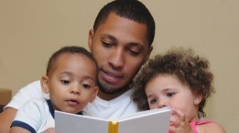
As parents, you are your child’s most influential teacher with an important part to play in helping your child to learn to read. Here are some suggestions on how you can make this a positive experience:

- Choose a quiet time
Set aside a quiet time with no distractions. Ten to fifteen minutes is usually long enough.

- Make reading enjoyable
Make reading an enjoyable experience. Sit with your child. Try not to pressurise if he or she is reluctant. If your child loses interest, then do something else.

- Maintain the flow
If your child mispronounces a word, do not interrupt immediately. Instead, allow opportunity for self-correction. It is better to tell a child some unknown words to maintain the flow rather than insisting on trying to build them all up from the sounds of letters. If your child does try to ‘sound out’ words, encourage the use of the letter sounds rather than ‘alphabet names’.

- Be positive
If your child says something nearly right to start with, that is fine. Don’t say ‘No. That’s wrong,’ but ‘Let’s read it together’ and point to the words as you say them. Boost your child’s confidence with constant praise for even the smallest achievement.

- Success is the key
Parents anxious for a child to progress can mistakenly give a child a book that is too difficult. This can have the opposite effect to the one they are wanting. Remember ‘Nothing succeeds like success’. Until your child has built up his or her confidence, it is better to keep to easier books. Struggling with a book with many unknown words is pointless. Flow is lost, text cannot be understood and children can easily become reluctant readers.

- Visit the Library
Encourage your child to use the public library regularly.

- Regular Practice
Try and read with your child on most school days. ‘Little and often’ is best. Teachers have limited time to help your child with reading.

- Talk about the books
There is more to being a good reader than just being able to read the words accurately. Just as important is being able to understand what has been read. Always talk to your child about the book; about the pictures, the characters, how they think the story will end, and their favourite part. You will then be able to see how well they have understood and you will help them to develop good comprehension skills.

- Variety is important
Remember children need to experience a variety of reading materials e.g. picture books, hard backs, comics, magazine, poems and information books.

Please remember that we have an open-door policy and everyone at Potley Hill Primary School is here to support your child in every way as they start their school journey. If you have any questions regarding information found within this booklet or any other queries, then please do not hesitate to contact the School Office.

